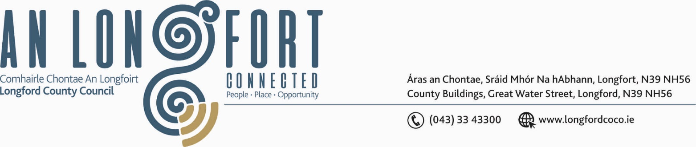

2u Feabhra 2017.

Chuig: Gach Ball don Chomhairle.

A Chomhairleoir,

Iarrtar ort bheith i láthair ag Cruinniú Míosuil Chomhairle Chontae Longfoirt a tionólfar i Seomra na Comhairle, Aras an Chontae, Longfoirt ar an Chéadaoin, 8u Feabhra 2017 ag 4.00 p.m chun gnó a dhéanamh d’réir an Chláir thíos.

You are requested to attend the Monthly Meeting of Longford County Council to be held in the Council Chamber, Aras an Chontae, Great Water Street, Longford, on Wednesday, 8th February 2017 at
4.00 p.m. to transact business, as set out on the Agenda.

Mise le meas,
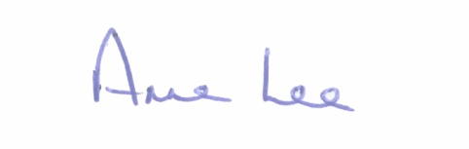

_______________
Anne Lee,
Meetings Administrator.



C L A R

Prayer before Meeting.

- Confirmation of Minutes of Monthly Meeting of Longford County Council held on the
11th January 2017 – copy enclosed.

2. Matters arising from Minutes.

3. To note Chief Executive Orders. (Summary herewith)

4. To note Monthly Management Report - report to follow.

5. To note adopted Minutes of Corporate Policy Group Meeting held on
14th December 2016 - (copy enclosed).

6. Economic and Community Development, Planning, Human Resources & Corporate
Services, Cultural & Recreational Services.

- To note Planning Applications received since January meeting of the Council.

- Notice of Motion submitted by Councillor Michael Carrigy.
“I call on Longford County Council to provide an Enterprise and Collaborative Space in Longford Town to act as a Digital Hub with all the associated services - High Speed Broadband etc. to attract new business into the town and create a vibrant environment for start up and established businesses to thrive.”

7. Housing, Infrastructure, Environment & Emergency Services.

- Consideration of the following recommendation from Granard Municipal District –

“That Longford County Council writes to the Minister for Transport, Tourism and Sport requesting additional funding for Local Improvement Schemes.”

- Notice of Motion submitted by Councillor Michael Carrigy.

“I call on the Minister for Health to provide extra funding for the provision of
long-term housing for people with special needs.”

8. Finance & Information Systems.

- To note Public Liability Claims received during January 2017 – report to follow.

- To note Longford County Council’s Performance Indicators 2015 - report enclosed.

- Transfer of amounts to Specified Revenue Reserves as part of Annual Financial Statement 2016 (list to follow).

- Notice of Motion submitted by Councillor Gerard Farrell.

“I call on Longford County Council to write to the Department of the Environment to consider re-adjusting the payment bands on property tax post 2019 to take into consideration rising house prices. I think there should be a middle band inserted. There is too big of a jump between the low band and the high band. Pensioners living on their own in old houses should also be given some consideration with a financial incentive.”

9. General

- Notice of Motion submitted by Councillor Michael Carrigy.

“I call on the Minister for Agriculture to organise the immediate payment of all GLAS monies due to farmers.”

(b) Correspondence - attached.

- Letter dated 11th January 2017 received from the Office of the Minister for Housing in relation to backyard services.
- Letter dated 17th January 2017 received from the Office of the Minister for Arts, Heritage and the Gaeltacht in relation to the Heritage Bill 2016.

10. Votes of sympathy.

11. Training -

Consideration of Report from Corporate Policy Group.

